** East West University**

**Course No: CSE109 Lab**

**Experiment Number:** 01

**Experiment Name:** Verification of Kirchhoff's Voltage Law(KVL) and Voltage Divider Rule(VDR)

**Date of Experiment: 22/9/2016**

**Date of submission: 29/9/2016**

**Group: 5**

**ID: 2016-1-60-053**

**2016-1-60-057**

**2016-1-60-058**

**2016-1-60-060**

**Experiment Number:** 01

**Experiment Name:** Verification of Kirchhoff's Voltage Law(KVL) and Voltage Divider Rule(VDR)

**1. Objectives:** The objectives of this experiment are to learn,

(i) The connection of a DC series circuit in breadboard.

(ii) The measurement procedures of voltage and current using multi-meter and ammeter.

(iii) Verification of KVL and VDR by using laboratory experiment.

**2. Equipment / Apparatus:**

(i) DC Voltage Source (01)

(ii) Resistors (0.47 k, 1 k, 1.5 k )

(iii) Multi-meter (01)

(iv) Ammeter(01)

(v) Breadboard

(vi) Wires

**3. Experimental Setup:**

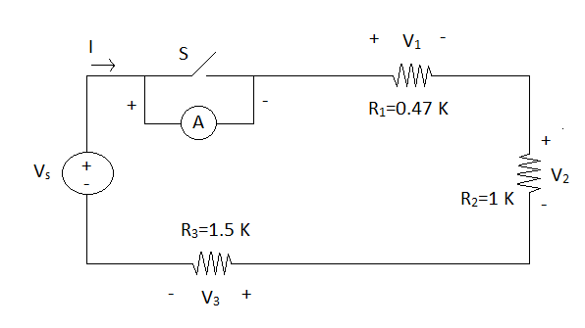

**Fig. 1**

**4. Procedure:**

(i) Measure the resistance of the resistors be using the multi-meter.

(ii) Connect the circuit as shown in **Fig. 1** in breadboard.

(iii) Turn on the DC voltage source and measure it's voltage **Vs** by using the multi-meter. Adjust the voltage changing KNOBs of the voltage source such that the output voltage becomes **I5 V**.

(iv) Measure the voltage **V1**, **V­­2** and **V3** across the three resistors by using the multi-meter.

(v) Open the switch **S** and measure current **I** by using the ammeter. Close the switch and open the ammeter.

(vi) Perform the calculation below.

**5. Data Table:**

|  |  |  |  |  |  |  |  |
| --- | --- | --- | --- | --- | --- | --- | --- |
| R1 (K) | R2 (K) | R3 (K) | Vs (V) | V1 (V) | V2 (V) | V3 (V) | I (mA) |
| 0.435 K | 0.920 K | 1.393 K | 15 V | 2.40 V | 5.01 V | 7.02 V | 5.1 mA |

**6. Calculation:**

(i) V1 + V2 + V3 = (2.40 + 5.01 + 7.02) V = 14.43 V

(ii) 100 * (Vs- ( V1 + V2 + V3)) / Vs = 100 * (15 V - (2.40 V + 5.01 V +7.02 V)) / 15 V

= 3.8 V

(iii) Rs = R1 + R2 + R3 = (0.435 + 0.920 + 1.393) K = 2.748 K

(iv) Req = Vs / I = (15 / 5.2) = 2.88

(v) 100* (Req - Rs) / Req = 100*(2.88 - 2.748) / 2.88

= 4.583

**7. Questions & Answers:**

(i) Do the experiment results verify the KVL ? Why are you getting some discrepancies ?

**Answer:** From KVL law we know, the algebraic sum of the voltage drops in a closed circuit is equal to the voltage we applied.

Here, our applied voltage Vs is 15V and the sum of V1, V2, and V3 is 14.43V. Those two have a little difference. So we can say the experiment results verified the KVL.

As we take the approximate value for our measurement, so we get little difference with the actual.

(ii) Do the experiment result verify the VDL ? Why you are getting some discrepancies ?

**Answer:** From VDL we know,

V1 = (Vs *R1) / (R1 + R2 + R3) = 2.374

V2 = (Vs *R2) / (R1 + R2 + R3) = 5.021

V3 = (Vs *R3) / (R1 + R2 + R3) = 7.603

These values are around to our experimental values of V1, V2 andV3 . So the experiment result verified the VDL.

We get some difference for our approximate measurement and also the mechanical error of multi-meter.

(iii) What is the percentage of difference between Rs and Req ? What are the possible reasons for getting this difference ?

**Answer:** The percentage of difference between Rs and Req is 1.32%. The possible reasons for getting differences are for the internal resistance of wire and also for environment.

**8. Discussion:**

(i) For measuring current we have to use the exact value of ammeter Errors less than 103 will be ignored.

(ii) Measuring the resistance of resistors we have to remember that human hand can effect on the value of resistance. We have to avoid them.

(iii) When calculating data we should be very careful for approximate values.